BDSH Foremost Report – TWO.dd
Contents
No table of contents entries found.

Report
16 FILES EXTRACTED
jpg:= 7
ole:= 5
zip:= 2
png:= 1
pdf:= 1

Files

JPG

00000552.jpg
Appears to be a low-quality photo of a cruise ship out at sea.


00001840.jpg
Appears to be a photo of cars driving on a highway.
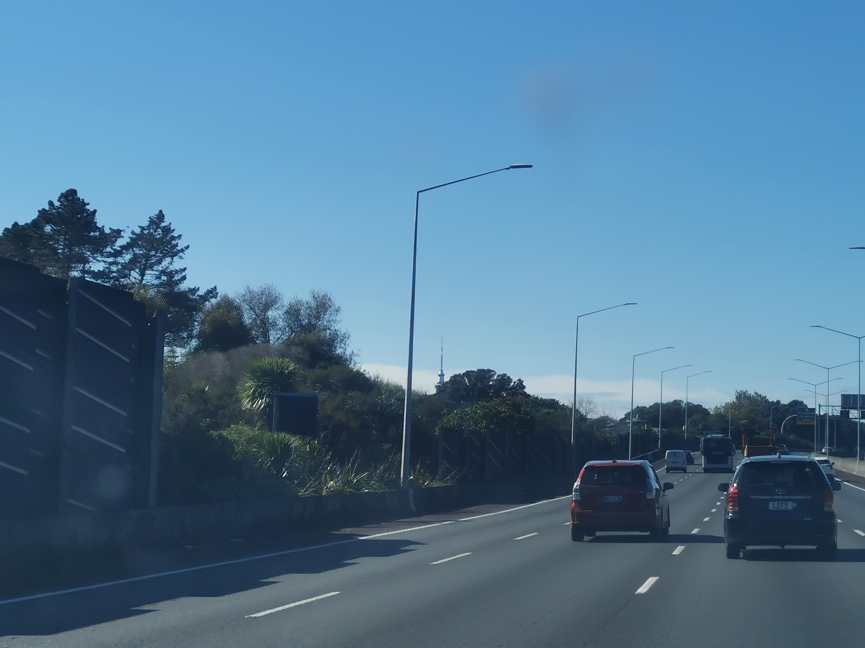

00004928.jpg
Appears to be a photo of a burned out power board.
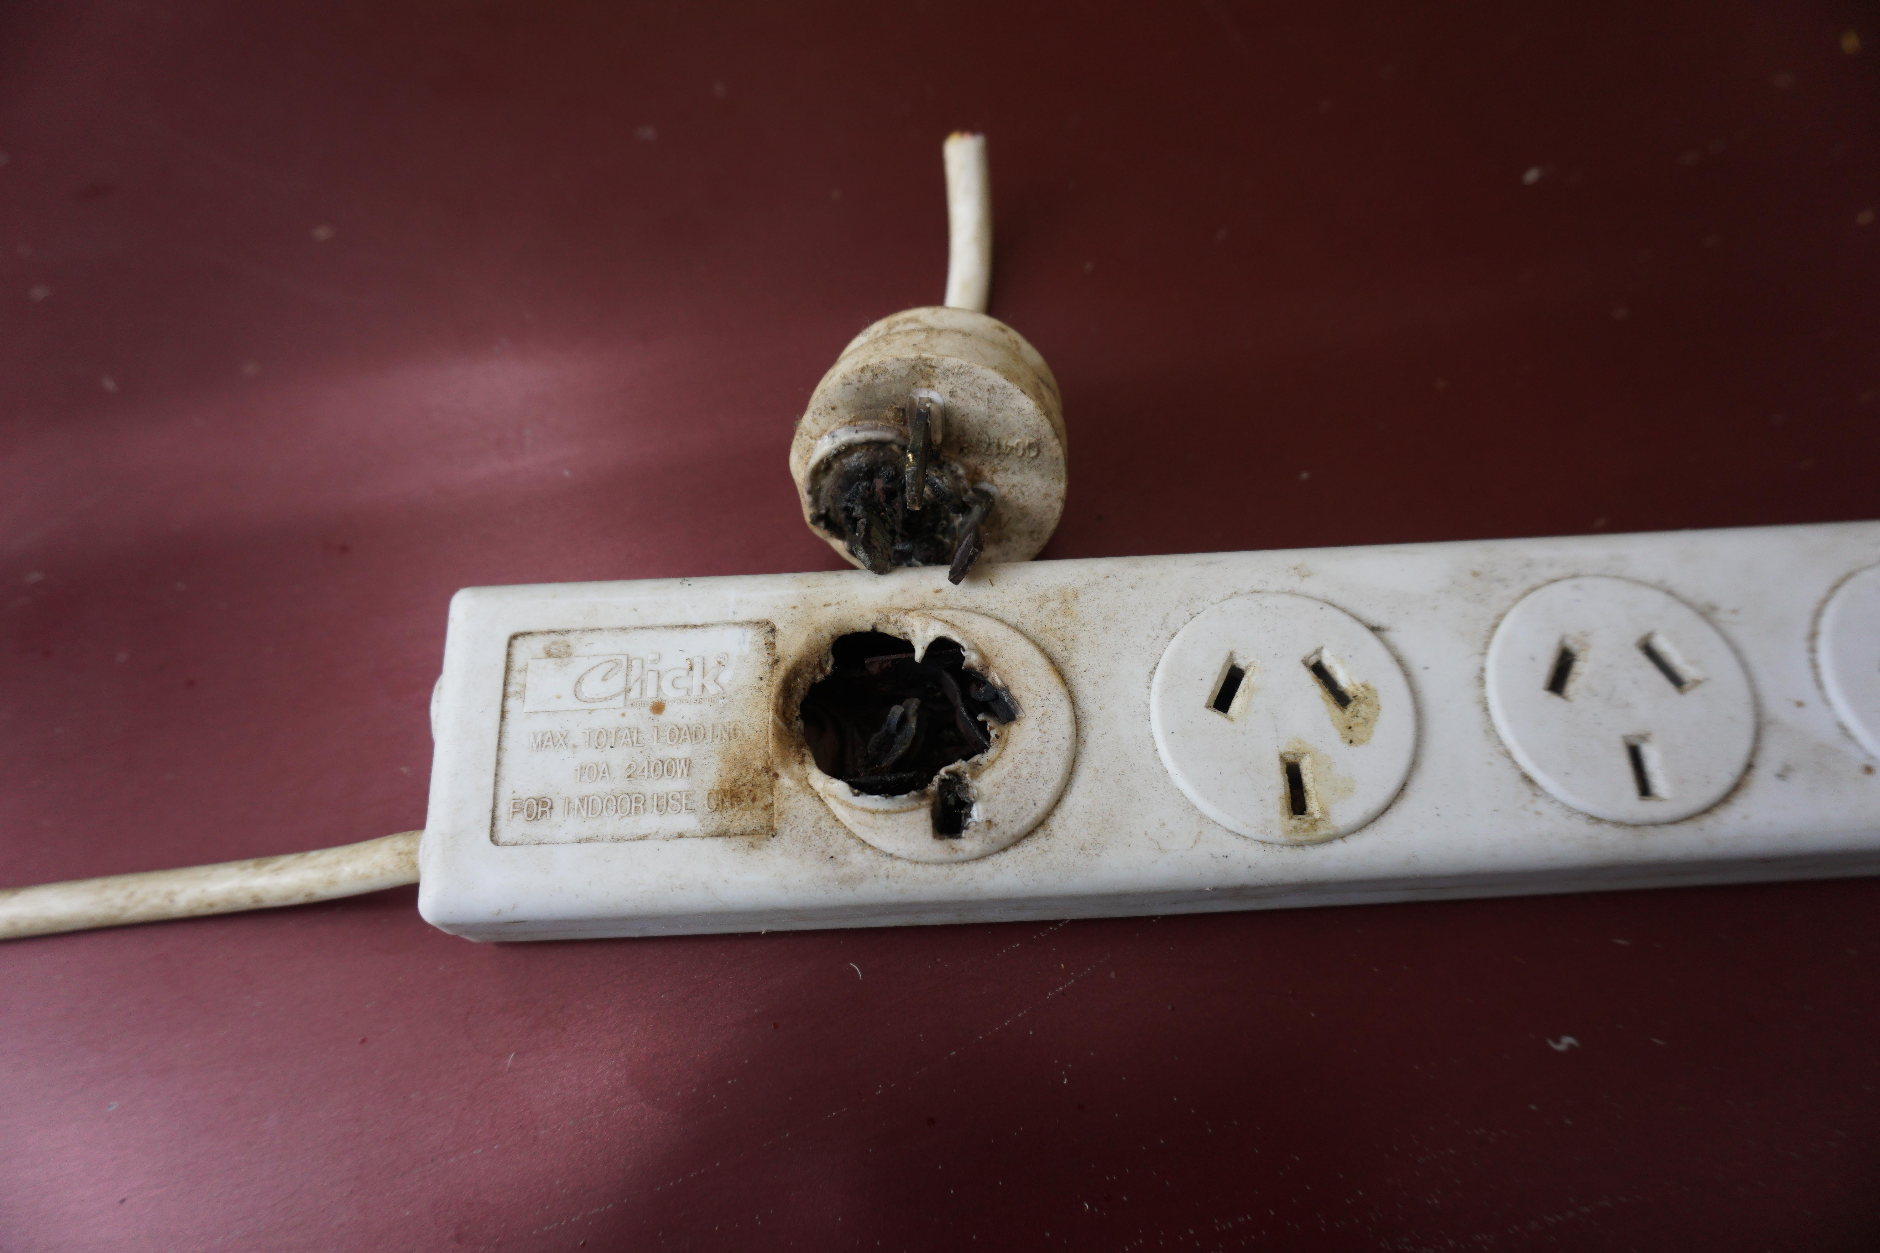

00006993.jpg
Appears to be a photo of an old black and white photograph of a sports team, with the words “The New Zealand football team which has been so successful in England.” written underneath.
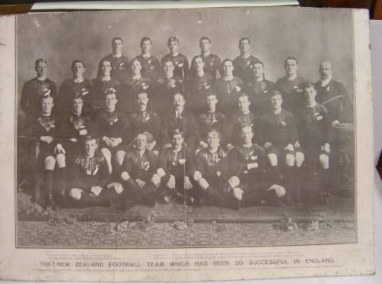

00007808.jpg
Appears to be a photo of the Sydney Opera House with a red trim and a rose insignia decoration.


00009632.jpg
Appears to be a photo of an electronic thermometer displaying 990 degress, however other text on the display indicates that it is being held upside down, and actually reads 066 degrees.
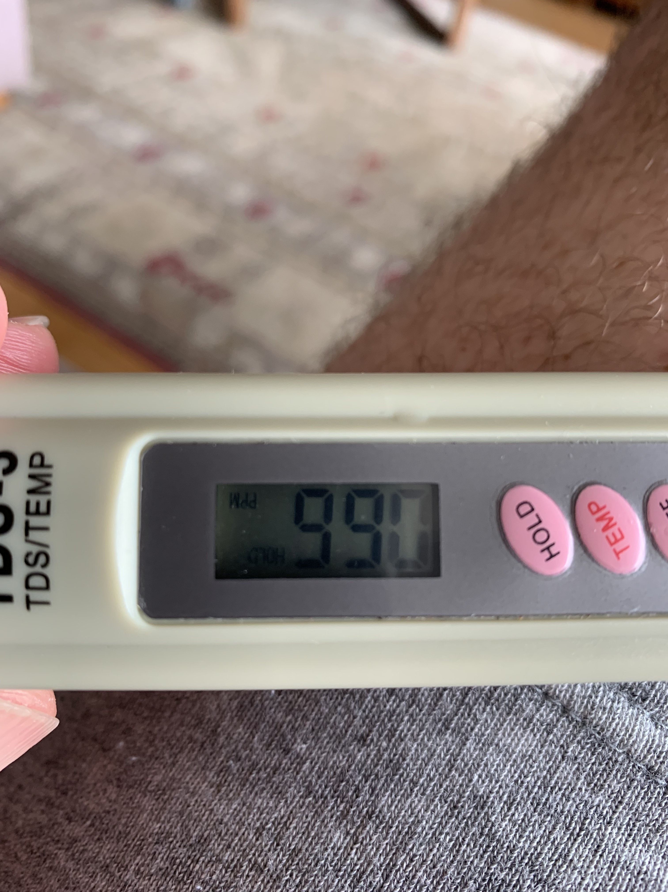

00014272.jpg
Appears to be a low-quality photo of a kitten sitting on a chair at a bench with its paw raised above its head.
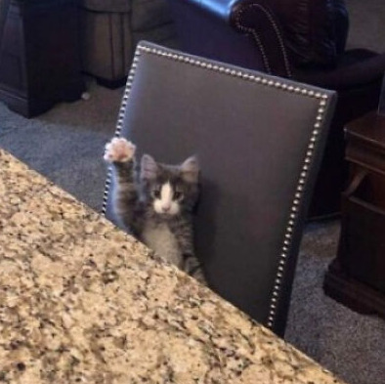

OLE

00006904.ole
Contains the text “Hidden 1 Where is the hidden message in this document?” Below, the words “OK you found me” is repeated 15 times in white text, hidden against the white background.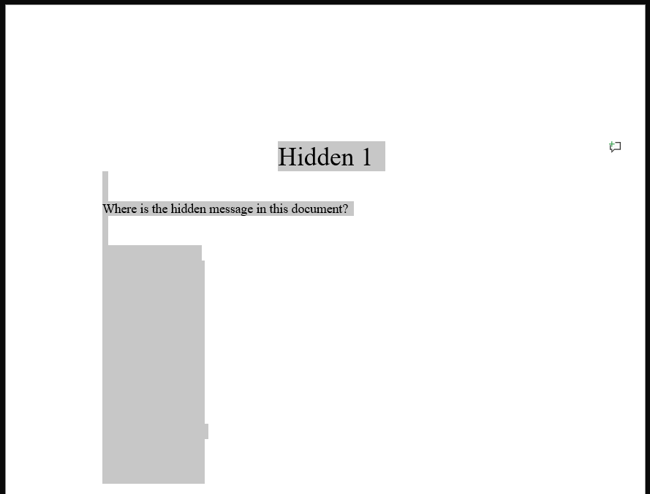

00006944.ole
Contains the text “Hidden 2 Where is the hidden message in this document?” Below, the words “OK you found me” is repeated 15 times, hidden behind a white image. 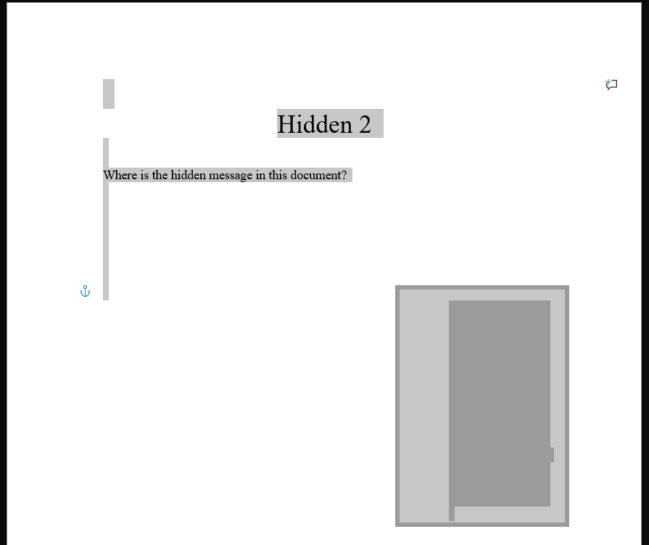

00006984.ole
Contains the text “Hidden 3 Where is the hidden message in this document”.
The image 00006993.jpg is present, shrunken down to the point where it appears to be the full stop at the end of the sentence.
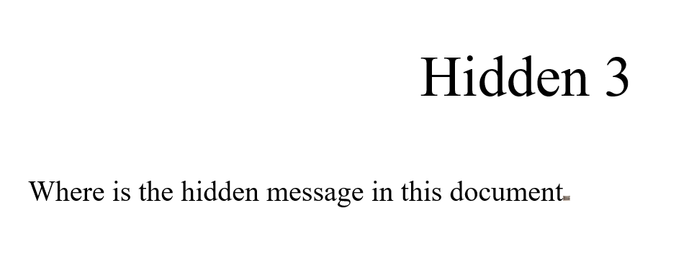

00007072.ole
A spreadsheet containing a person’s exam results. Scrolling down to line 2652 reveals an image of a wet soapy cat.
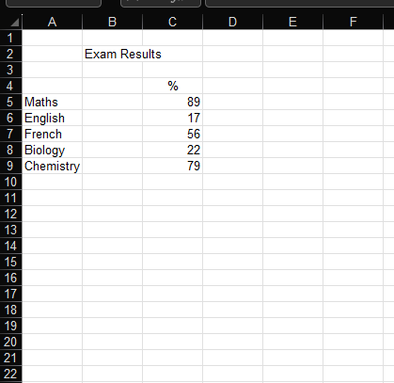
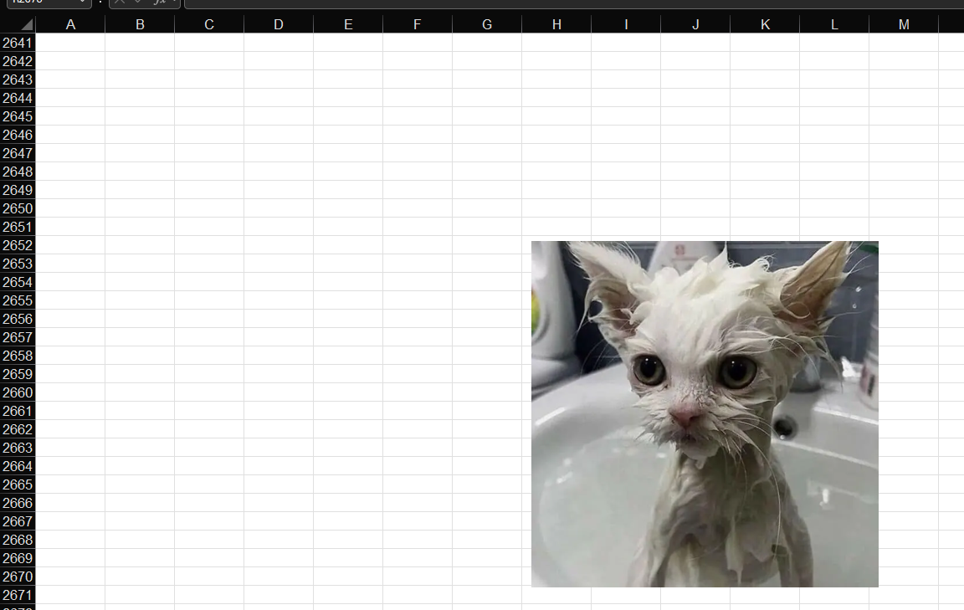

00007800.ole
Contains the text “Hidden 5 Hey this is a great picture of what the Aussies had to do to the Sydney Opera House when they lost to the English.” Underneath is 00007808.jpg. Hidden behind the image is 00007956.png
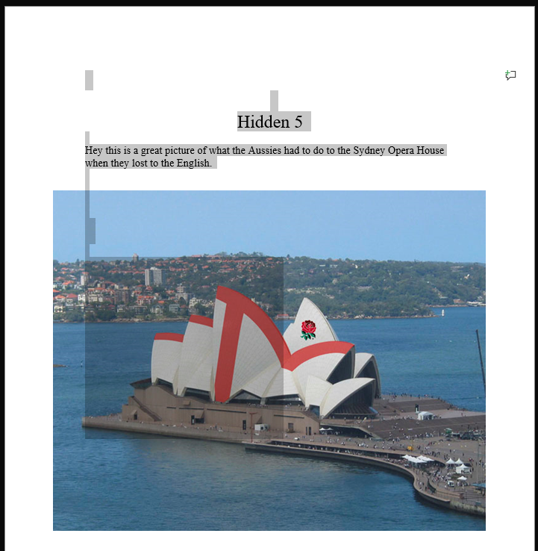
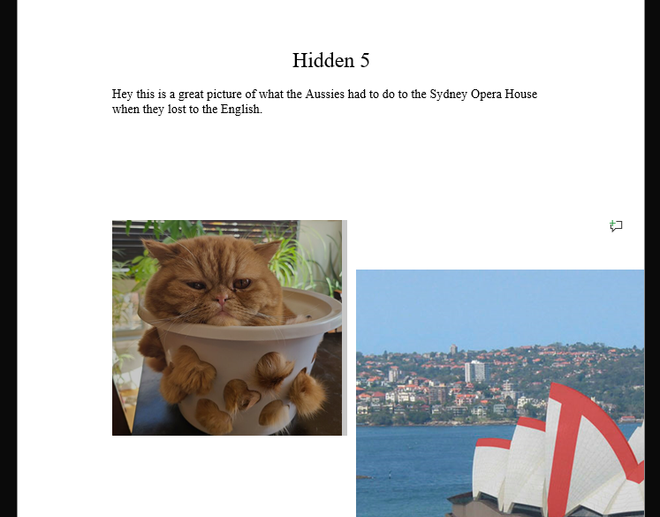

ZIP

00007760.zip

00009314.zip

PNG

00007956.png
Appears to be a photo of a cat sitting in a white bucket with heart-shaped holes in it, the cat’s fur poking through the bucket’s holes.


PDF

00014376.png
The pdf is encrypted and cannot be accessed without a password.

